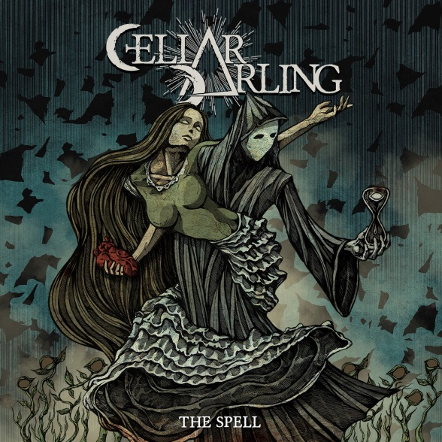

CELLAR DARLING
»The Spell«

out March 22nd, 2019

Line-up: | CELLAR DARLING online:
Anna Murphy - vocals, hurdy-gurdy, multi-instrumentalist  Merlin Sutter - drums  Ivo Henzi - guitars, bass | www.cellardarling.com  www.facebook.com/cellardarlingofficial  www.twitter.com/cellar_darling  www.instagram.com/cellardarlingofficial/  www.vk.com/cellardarling

CELLAR DARLING’s second full-length »The Spell« weaves a dark fairytale for the modern era, told through heavy yet intricate, progressive folk rock, enchanting visual art and utterly immersive storytelling. The band began in 2016 after Anna Murphy (vocals, hurdy-gurdy), Merlin Sutter (drums) and Ivo Henzi (guitars and bass) left Swiss folk metallers ELUVEITIE, which they had all played in for over a decade. But they weren’t ready to end their musical journey together yet, and embarked on a new and different path

“We’re happy that ELUVEITIE fans have joined us, but we didn’t want to do the same thing with CELLAR DARLING: we want to do our own thing,” explains Merlin. “With CELLAR DARLING, we deliberately didn’t set ourselves any limits – and that really enabled us to find the type of music that we wanted to play.”

Anna originally used the name CELLAR DARLING for her own solo album in 2013, but it also perfectly encapsulated their vision for this new adventure. “Our music stems from ideas that were kept hidden away in a type of creative cellar, and are now ready to see the light,” Anna explains. “It also visualises our music: the darkness is the cellar, and ‘darling’ represents something light and beautiful.”

The three-piece introduced these spellbinding sounds to the world with their debut album »This Is The Sound« in 2017. But for »The Spell«, they decided to take their musical ideas and creativity one step further, and to make a concept album, after the initial idea for »The Spell« came to Anna randomly while she was out hiking with her father. It tells the tale of an unnamed girl who is birthed into a world that is full of pain, damaged and debilitated by the human beings that inhabit it. We follow her as she searches for meaning in life, when suddenly she meets and falls in love with death – concluding with an ambiguous ending that leaves the listener wondering. Though Anna set out to create abstract rather than autobiographical lyrics, »The Spell« became a personal journey for her.

“Even if you write completely abstract lyrics, it is based on your life and personality somehow,” she says. “It was strange, because even though it was a dark concept, when I created it I was feeling happy. But then, as we were working on the album, my mental health got really bad – worse than ever before. It was as if the creative part of my brain was realising what state I was in before I became fully conscious of it.” But focusing on the album helped Anna to work through these demons: “The music is always my outlet,” she says. “Without it, I probably wouldn’t be here anymore.”

Though it was Anna who conceived the concept of the album, CELLAR DARLING is very much a collaborative effort. “A song that is written by only Ivo or myself would not sound like Cellar Darling,” says Anna firmly. “That is what makes this band special.” “It was something new for me,” adds Ivo on the experience of writing music around a concept for the first time. “It was challenging, but after 12 years of making music, it was really good for my musical experience. It gave us something to focus on.” “I think the lyrical concept definitely helped in making the album a coherent whole,” Merlin adds.

On »The Spell«, CELLAR DARLING have cemented their sound. Juxtaposing darkness and light, the album soars with melody, pummels with heavy passages and is peppered throughout with progressive flourishes, folky interludes and classical elements, as well as their use of hurdy gurdy and flute. “I think prog fits us best,” says Merlin. “Prog isn’t just about guitar solos, long songs or technical ability: for me, it’s pushing the limits of genre. We don’t want to set any boundaries for ourselves, and to me, that is the definition of progressive music.” His enthusiasm for grandiose rock and prog bands like QUEEN and DREAM THEATER shines through in »The Spell«, and it comes as no surprise that Anna is the child of two professional opera singers, as her stunning vocals glide majestically throughout this ambitious album.

But the ambition of »The Spell« doesn’t stop with the music and lyrics: CELLAR DARLING have created an audiobook that’s narrated by Anna to help complement the album’s story, and they enlisted Romanian graphic designer, Costin Chioreanu (OPETH, ULVER, WARDRUNA and more) to create vivid illustrations and animated videos for every track.

“He’s the artwork rock star in the metal scene!” laughs Anna. “I was a huge fan of his – I actually have a sleeve tattoo with artwork that he did for ULVER. So I got in touch with him about that and kept in touch ever since. He’s an amazing artist: we just sent him the music and lyrics, and he delivered.”

For CELLAR DARLING, the intricate artwork is central to the album. “Even now when I am listening to an album, I like to be able to look through the artwork,” Merlin says. “To hold the sleeve in your hand while you listen. It’s very much a part of the album experience, in my opinion: I grew up with my dad’s record collection, he had something like 10,000 vinyl! It was a more deliberate way of listening to music. It’s amazing that now WE have something like this, that you can actually spend some time looking at while listening to the music. So I think it’s amazing that we are able to make the artwork available digitally as well, in the form of animated videos for each and every track, and on our website, too.”

“It gives more importance to the concept,” Anna concludes. “Having something like a bonus track would have been great, but it wouldn’t have completed what we started. With the audiobook and the fitting artwork, it closes the circle.”

